CSS Basics
Definition of CSS: CSS (Cascading Style Sheets) is a stylesheet language used to describe the presentation of a document written in HTML or XML. CSS controls the layout and appearance of web pages, separating content (HTML) from design. It allows developers to style elements, control layout, and enhance user experience by modifying things like colors, fonts, spacing, and responsiveness.
Role of CSS in Web Development:
- Styling: CSS gives developers control over the appearance of HTML elements like colors, fonts, and sizes.
- Separation of Content and Design: HTML provides the structure, while CSS handles the styling, making maintenance easier.
- Responsive Design: CSS enables websites to adapt to different screen sizes and devices (e.g., mobile, tablet, desktop).
- Consistency: By applying the same CSS stylesheet across multiple pages, a consistent look and feel can be maintained throughout a website.
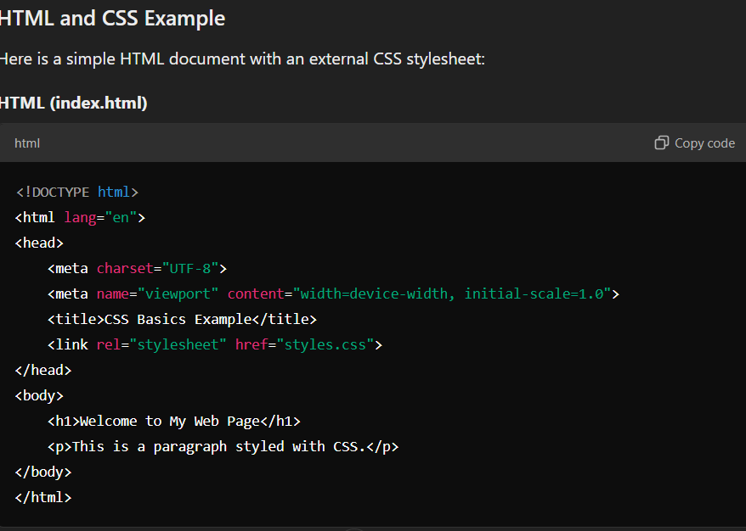
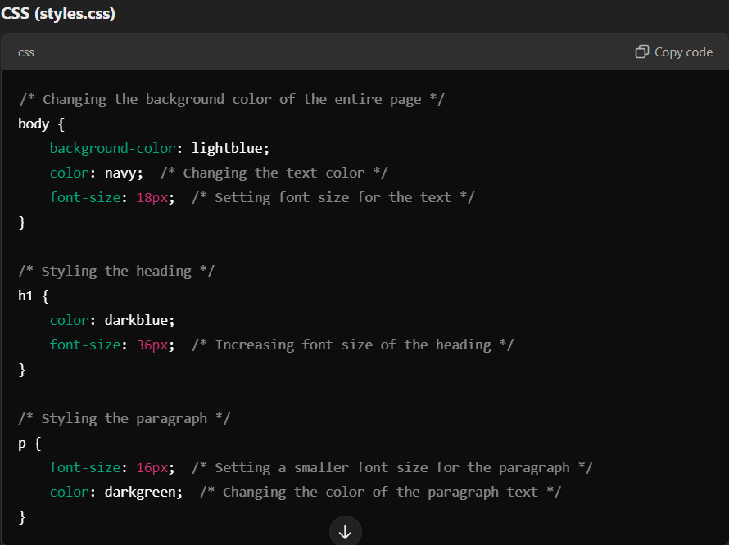

Explanation of the Code:
- HTML Document:
  - The HTML file is a simple web page with an h1 element (heading) and a p element (paragraph).
  - The <link rel="stylesheet" href="styles.css"> tag in the <head> section links the external CSS file (styles.css) to the HTML document. This ensures that the styles defined in the CSS file are applied to the HTML elements.
- CSS Stylesheet:
  - The body selector targets the entire page. The rules inside the body will affect everything in the document.
    - background-color: lightblue;: Changes the background color of the page to light blue.
    - color: navy;: Changes the default text color of all text elements to navy blue.
    - font-size: 18px;: Sets the default font size for the text on the page to 18 pixels.
  - The h1 selector targets the heading element:
    - color: darkblue;: Changes the heading text color to dark blue.
    - font-size: 36px;: Increases the font size of the heading text to 36 pixels, making it larger than the body text.
  - The p selector targets the paragraph element:
    - font-size: 16px;: Sets the font size for paragraph text to 16 pixels, slightly smaller than the default text.
    - color: darkgreen;: Changes the paragraph text color to dark green.

